**‘Make It New’**

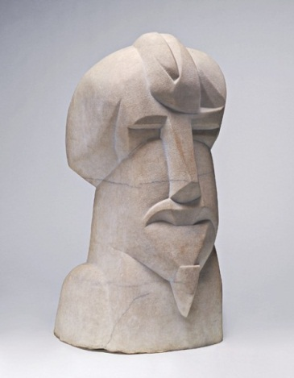Ezra Pound’s modernist imperative and his 1934 collection of essays by the same name. ‘Make It New’ compels the writer to create out of the material of art work that is distinctively innovative. The artist must break with the formal and contextual standards of his or her contemporaries in making works fundamentally individual. These ‘new’ modern works cannot be wholly autonomous however as they must consider the aesthetics of the past in the context of the present moment. The term first appears in Pound’s ‘Canto LIII’ (written in the early 1930s) in the form of Chinese ideograms that he is said to have taken from a Shang imperial bathtub. The term is not limited to Pound’s work as it describes a prevalent attitude in modernism. One can trace the idea of ‘Make It New’ to the early avant-garde literary and artistic movements at the beginning of the twentieth century (i.e. [imagism](http://dl.lib.brown.edu/repository2/repoman.php?verb=render&id=133157561387302&view=pageturner), vorticism, futurism, and others). An edict characteristic of the principles of modernism, ‘Make It New’ calls the artist to react against historical conventions while simultaneously engaging in a dialogue with literary and cultural traditions.

**References and Further Reading**

1. Pound, Ezra (ed.). *Des Imagistes*.

This first anthology of imagism is an effective example of early efforts to ‘make it new’ in poetry. The collection includes some of the most recognisable modernist writers such as H.D., Ford Madox Ford, James Joyce, Amy Lowell, Ezra Pound, William Carlos Williams, and others.

2. Pound, Ezra. *Make It New*.

This collection of essays is the first published pronouncement of ‘Make It New’.

3. Kenner, Hugh. *The Pound Era*.

Kenner’s book takes the perspective of Pound’s influences on modernism, both direct and indirect. The accessible narrative approach to the subject matter and its index and notes are particularly valuable.

4. Levenson, Michael. *Modernism*.

A work with an emphasis on modernism’s internationalism, Levenson’s book takes a broad approach to the early decades of the twentieth century that gives an account of the widespread attitude to ‘make it new’. Its index and notes are of great value for further study on the topic of ‘make it new’ and on modernism in general.

**Image URL:** <http://images.tate.org.uk/sites/default/files/styles/grid-normal-8-cols/public/images/henri%20gaudier-brzeska%20hieratic%20head%20of%20ezra%20pound%201914.jpg>

**‘Imagism’ URL:** <http://dl.lib.brown.edu/repository2/repoman.php?verb=render&id=133157561387302&view=pageturner>